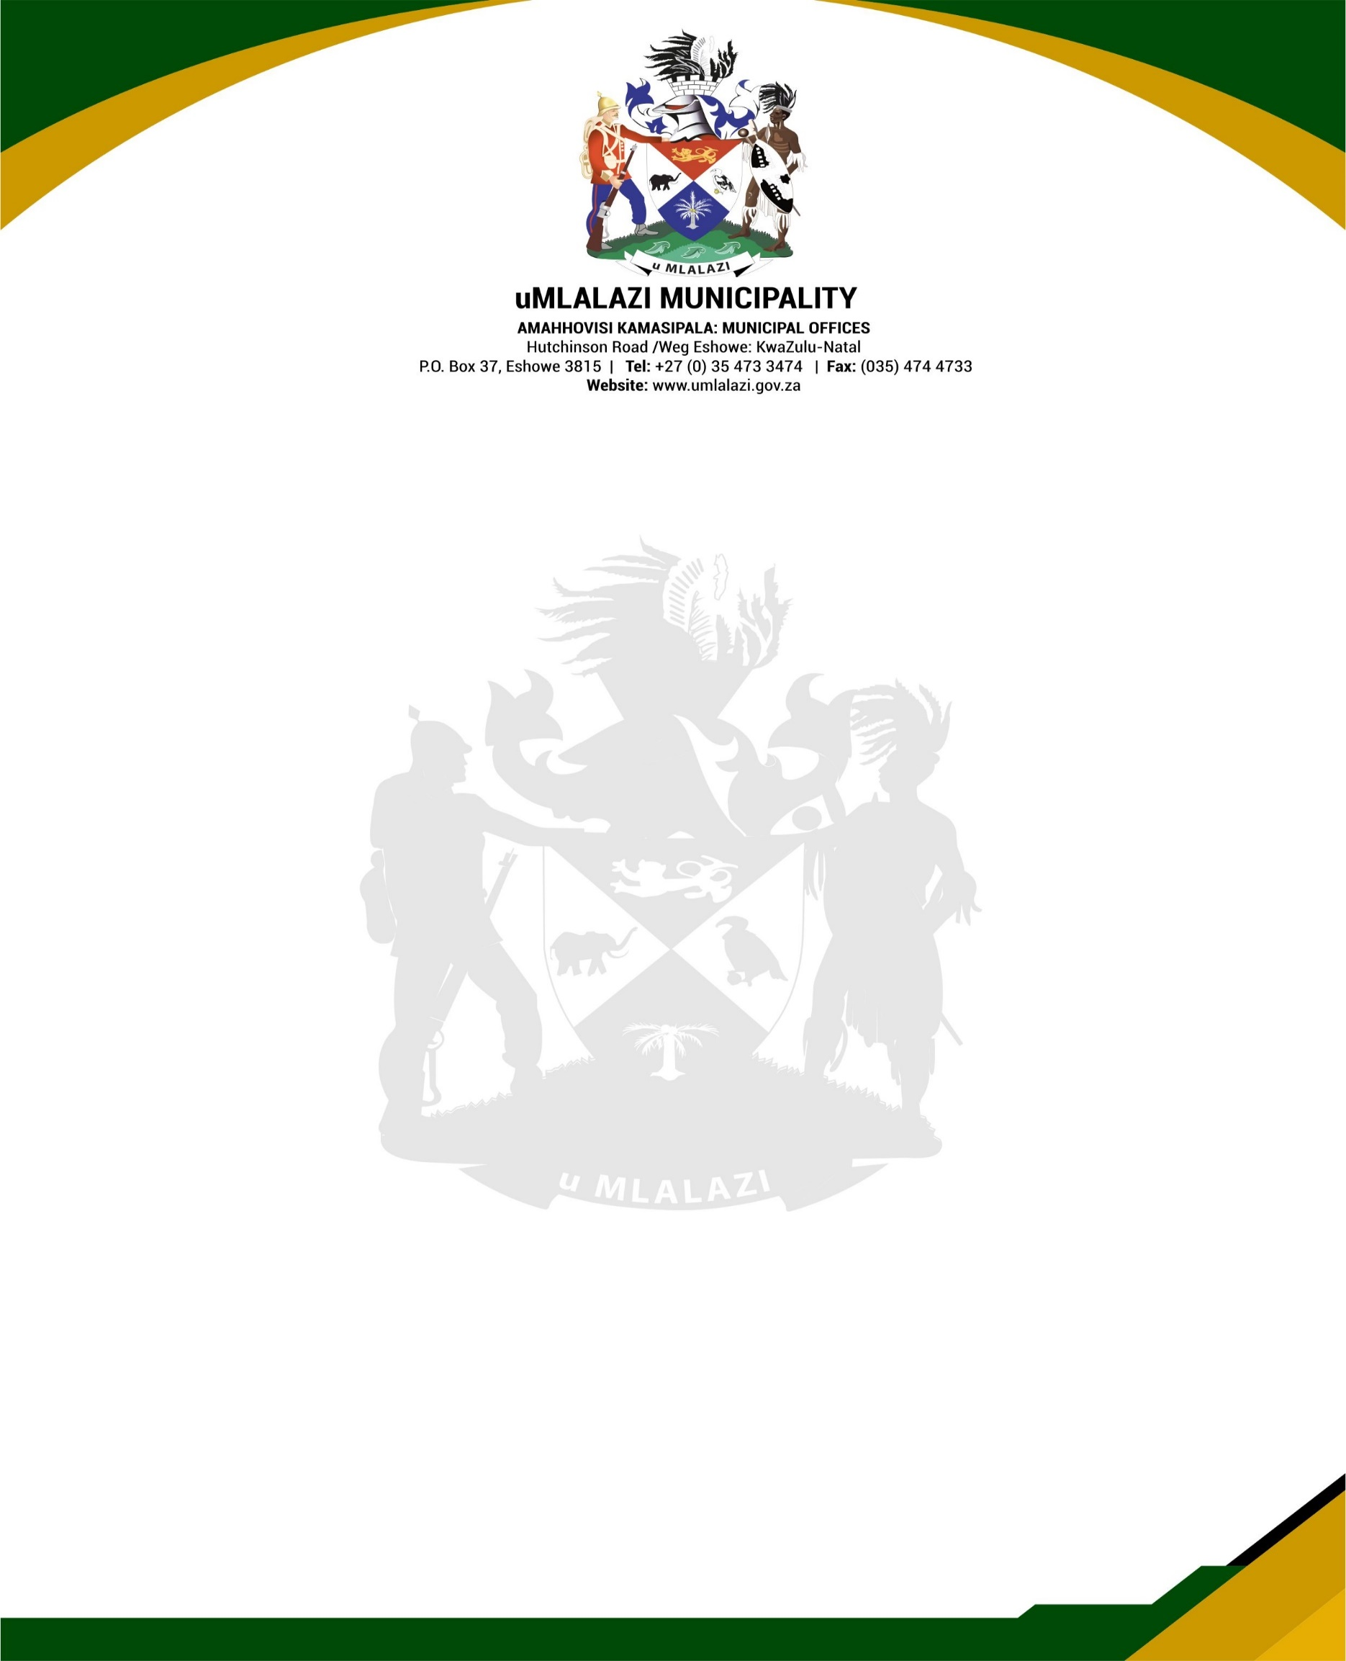.

PUBLIC NOTICE

Following the closure of Municipal Libraries as a result of the COVID – 19 outbreak, Library users are informed that the following public libraries will open on Monday, 19 October 2020 from 9h00 to 15h00, Mondays to Fridays.

1. **Eshowe Library**
2. **King Dinuzulu Library**
3. **Sunnydale Library**
4. **Gingindlovu Library**
5. **Mtunzini Library**
6. **Mbongolwane Mobile Library**

Please note that the Library Services will be limited and the Library users are requested to cooperate with the Library staff to ensure compliance with Alert Level 1 National Lock down regulations. The applicable rules outlining the services available/restrictions are obtainable at the respective Libraries.

**# Stay Safe**

**#Wash hands**

**# Observe Social Distancing**

Issued by

**MANAGEMENT**